Pink Day – 2019
T-shirt Order Form
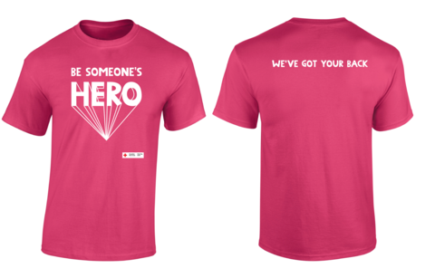

Shoal Lake School will be participating in the Red Cross Pink Day on Feb. 27, 2019.
Pink Day began when two boys chose to take action against bullying behaviour by encouraging their peers to wear pink. Their actions sparked a world-wide movement shedding light on the issues surrounding bullying and inspiring others to Be Someone’s Hero by speaking up when they see bullying happening.
On Feb. 27, SLS will be participating in this cause by wearing pink. If you would like to order the most current Red Cross t-shirt here is the order form. All proceeds from shirt sales support local Red Cross bullying prevention programs.
The deadline for ordering t-shirts is February 1. Cheques can be made payable to Shoal Lake School. The cost of a youth t-shirt is $8.40 and the cost of an adult t-shirt is $9.04.
Please indicate Y in front of size for youth and an A in front for adult
Size | Quantity | Total Cost

Please print name clearly:_________________________________________

Total of Tshirts ordered
Total Amount of Money attached to order

Adult Short Sleeve Tee - MEASURED IN INCHES
Size | S | M | L | XL | 2XL | 3XL | 4XL | 5XL
Chest Across (Width) | 18 | 20 | 22 | 24 | 26 | 28 | 30 | 32
Body Length | 28 | 29 | 30 | 31 | 32 | 33 | 34 | 35

Youth Short Sleeve Tee - MEASURED IN INCHES
Size | XS | S | M | L | XL
Chest Across (Width) | 16 | 17 | 18 | 19 | 20
Body Length | 18 | 20 | 22 | 23 | 25
Measured in inches.

